Agenda 5: Secretary’s Report

Report of the Secretary
To the 64th Board of Directors’ Meeting of ACCU
on September 25, 2008, Dhaka Sheraton Hotel, Bangladesh

The minutes of the Board Meeting on March 28, 2008 held in Korea was circulated to all Board Members.

ACCU recognizes the continued commitment of the National Credit Union Federation of Korea (NACUFOK) for its voluntary contribution of US$ 20,000 for the financial year 2007/2008.

CUNA Mutual Group has informed its decision to disaffiliate as Affiliate Member of ACCU.

The following members have informed their inability to attend the 26th General Meeting:

International Raiffeisen Union Germany

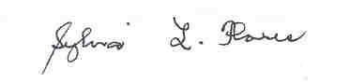

Dr. Sylvia L. Flores
Secretary

5.B.01

